Surge

|  |  |
| --- | --- |
| **Project Information** | |
| Project Name | Surge |
| Area | Racing Video Game |
| Document Location | GITHUB REPO |
| Spec Status | Initial Draft |
| Document Security | Public (All GitHub) (X) Private (Only Special Topics group) ( ) |

|  |  |
| --- | --- |
| **Contact Information** | |
| PM Author | Adi Suskic |
| Dev Author | Ryan Tiotuico |
| Design | Arthur Van Der Harst |
| Test Contact | 6th Period AP Computer Science |

|  |  |  |  |
| --- | --- | --- | --- |
| Revision Summary | | | |
| Author | Date | Version | Comments |
| Adi Suskic | 12-Sep-22 | 1.0 | Initial Draft |
| Adi Suskic | 9-Nov-22 | 1.1 | Revised Doc |
| Arthur Van Der Harst | 9-Jan-23 | 1.2 | Revised descriptions and pictures |
| Ryan Tiotuico | 9-Jan-23 | 1.3 | Further elaborated on AI and Car capabilities |
| Arthur Van Der Harst | 25-Jan-2023 | 1.4 | Removed powerup page  Expanded on User interface and Game Control |
| Ryan Tiotuico | 25-Jan-2023 | 1.4 | Added Boneyard & added Multiplayer + Powerups to it  Expanded on Game Control and |

# Game Description

The purpose of this project is to create a fun new racing game, SURGE, which is accessible to all. The user will control a car, navigate through a course, and try to achieve the best time possible. We were inspired by Super Mario Kart but wished to make a similar game with even better graphics and environmental setup



# 2 Car

* The user will be able to control the car with the arrow keys and WASD. The LEFT arrow key (A) will turn the car to the left, the RIGHT arrow key (D) will turn the car to the right, the Up-arrow key (W) will move the car forward, and the DOWN arrow key (S) will move the car back.
* Utilized Standard Assets UI features and the Flexible Color Picker imported package to allow the user to select color of car
* The user will be able to select a decal to change the design of the car using the Texture class of Unity
* The car will follow gravity and collider mechanics

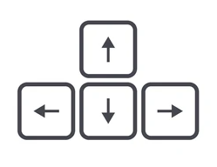

# Scenes

* The user will use the 3rd person perspective to drive the car
* Using the Unity RoadSystem package to have a tool to make tracks
* The terrain embedded in Unity could not import correctly so we are using the Procedural Terrain System package
* Using Stylized textures to add detail to terrain
* Will have different environments for each track made -Desert, Fire, Ice
* All terrains contain colliders that will act as triggers when the car falls off the track on to the terrain

**In progress:**

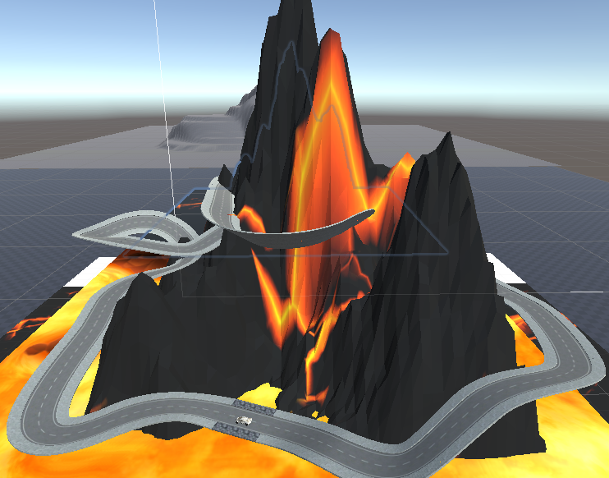

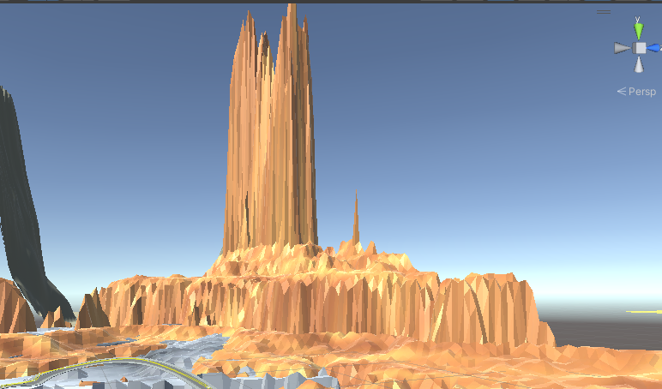

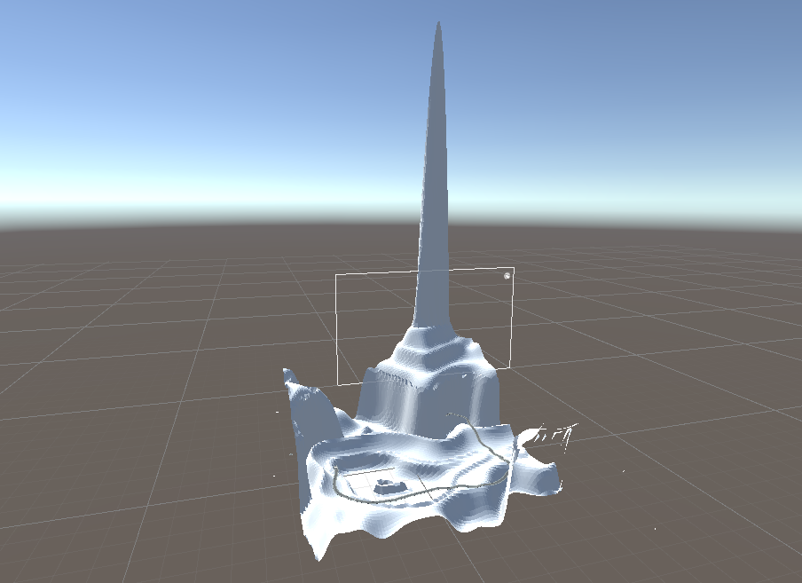

**Final:**

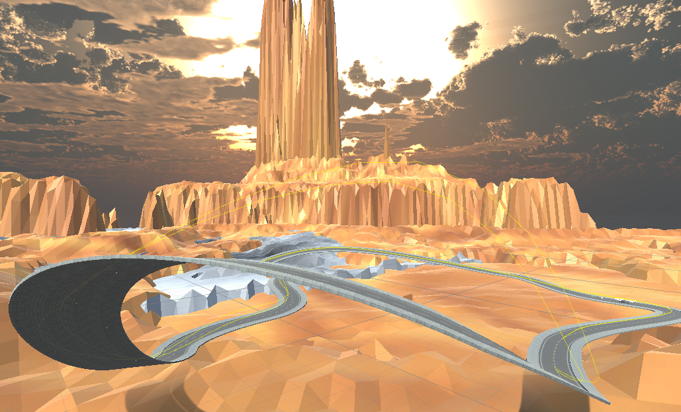

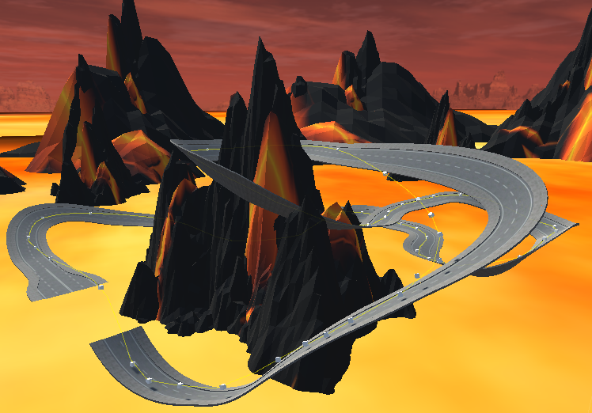

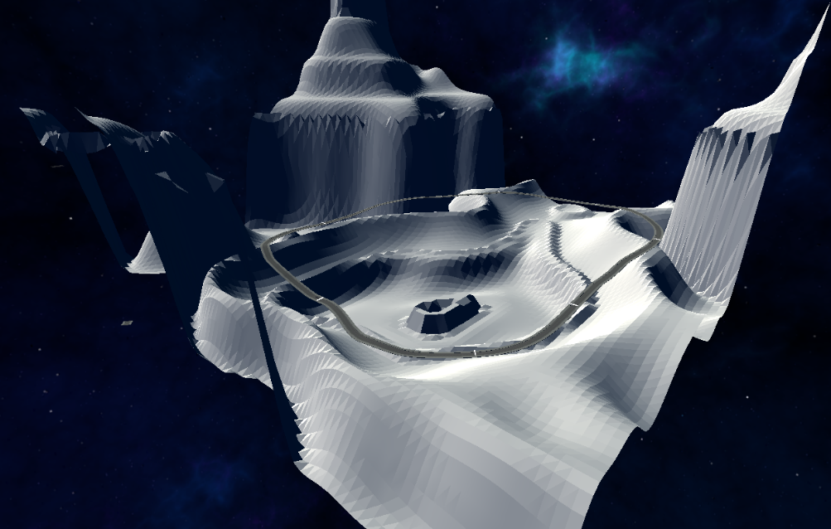

# 4 Timer

* Timer program has been made
* Uses the deltaTime method of the Time class to make it work like a stop watch
* Checks if you have past the given amount of checkpoints to know when to stop the timer
* Tracks total time spent on track, lap time, and the best lap time you have had
* Uses text UI from the Unity canvas to display time
* Lap time resets after every lap and total time stops after laps done is equal to the number of laps for that track
* When lap amount satisfied Boolean called “racing” is set to false stopping the game and toggling to one of two images depending if they won or loss

Uses the “FreezeAll” method of the RigidBodyConstraints class to freeze the car after it comes into contact with a object tagged “Death”.

* + It will also reset the velocity of the vehicle after teleporting it to the saved position and rotation to prevent the car from flying off at a random direction or speed.

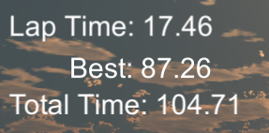

# 5 | Game Control Class

* When the user’s car passes through a rigid body with the tag “Respawn”, the “Reset to Checkpoint” script will realize this and save the position of that rigid body
* Does this by getting the position and rotation of our collider in code and saving it
* Then, if the car passes through a rigid body with the tag “Death”, the car will be teleported and frozen in place for a matter of time above the last saved position.
* Uses the “FreezeAll” method of the RigidBodyConstraints class to freeze the car after it respawns to allow the user to be ready and punish them by prolonging their time

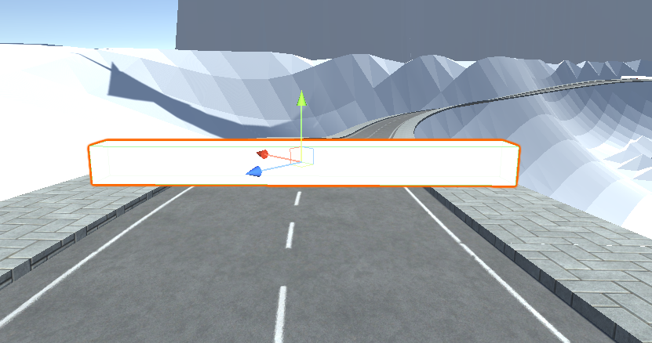

# 6 | Menu UI

* The user will start in a main menu where they can select the map they wish to play and change settings
* While the user is playing a map, they will also be able to press Esc and access a pause menu that will allow the user to change their car design and settings from within the game
* When the user presses the Escape key, the game will pause by setting the timescale to 0, and then open a canvas with the UI elements.
* The main menu button uses a script to open a different scene.
* The reset button restarts the current scene.
* The customize vehicle button opens a different part of the UI, and then uses the FCP system to allow the user to change the color of their car by changing the color of the car material.
  + The user can also change the decal of the car by using a script that replaces the car material with a different material.
* The give feedback button loads a URL to our feedback form.

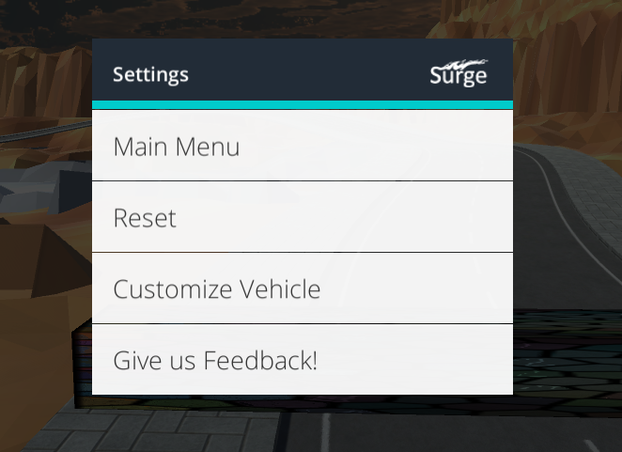

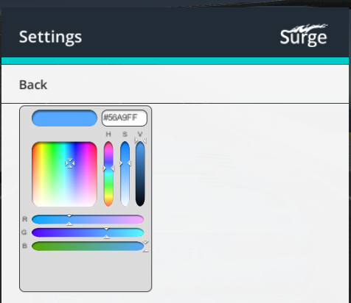

# 7 | AI Opponent

* Have AI opponents Level 1 and Level 3 of our game
* Challenges players to have to maneuver and prioritize speed to win
* Modified downforce, and acceleration and brake sensitivity to compensate for a car driven without human instincts
* Uses the WayPoint Circuit code of Standard Assets
  + Utilize 3D cube objects as “waypoints” that the code then uses to trace a path
  + Heavily tested so it can make jumps and even the sharpest turns

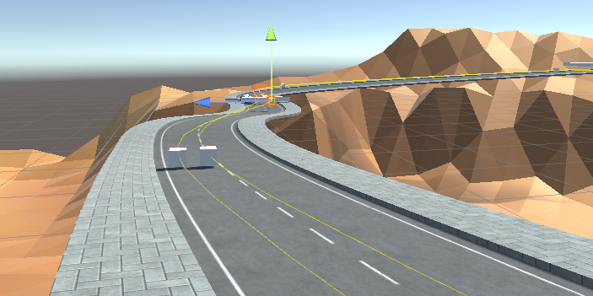

# 8 | BONE Yard

## Power Up

* Throughout the course there will be a “boost” powerup available.

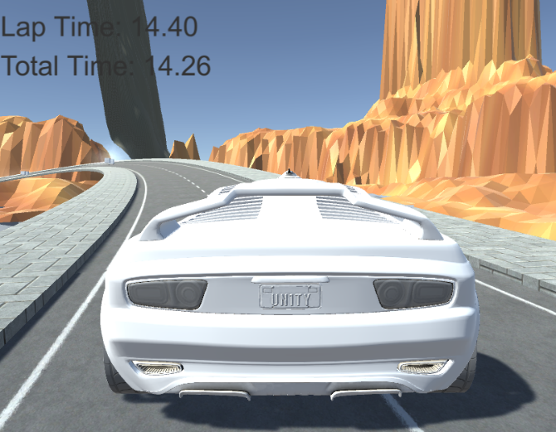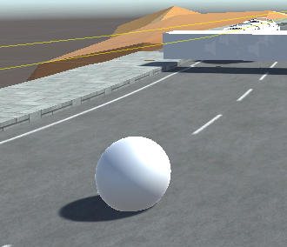

* Can increase or decrease the size of a car
* Still trying to revert the car when I want the powerup to “run out”
* Hope to make a powerup that can increase speed but having trouble with importing
* The Powerup will disappear once the user passes through the object.

## Multiplayer

* An interface that allowed others to play against each other on different devices
* Create a leaderboard to also track the times of all players who played our game